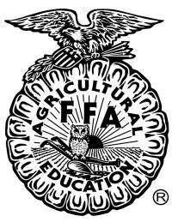
THE FFA CREED SPEAKER SCRIPT
THE FOLLOWING IS EXACTLY WHAT MUST BE RECITED:

“The FFA Creed by E.M. Tiffany

I believe in the future of agriculture, with a faith born not of words but of deeds – achievements won by the present and past generations of agriculturists; in the promise of better days through better ways, even as the better things we now enjoy have come to us from the struggles of former years.

I believe that to live and work on a good farm, or to be engaged in other agricultural pursuits, is pleasant as well as challenging; for I know the joys and discomforts of agricultural life and hold an inborn fondness for those associations which, even in hours of discouragement, I cannot deny.

I believe in leadership from ourselves and respect from others. I believe in my own ability to work efficiently and think clearly, with such knowledge and skill as I can secure, and in the ability of progressive agriculturists to serve our own and the public interest in producing and marketing the product of our toil.

I believe in less dependence on begging and more power in bargaining; in the life abundant and enough honest wealth to help make it so – for others as well as myself; in less need for charity and more of it when needed; in being happy myself and playing square with those whose happiness depends upon me.

I believe that American agriculture can and will hold true to the best traditions of our national life and that I can exert an influence in my home and community which will stand solid for my part in that inspiring task.

Thank you”

ALL RECITATION ERRORS (MISSED WORDS) MUST BE CIRCLED

Total # of Recitation Errors ________
(missed, added or switched words)

Question Time: ____________

Determination of Deductions

Number of errors ___ x 2 = ______

Total Deduction: ______
The creed was written by E.M. Tiffany, and adopted at the 3rd National Convention of the FFA. It was revised at the 38th Convention and the 63rd Convention.

