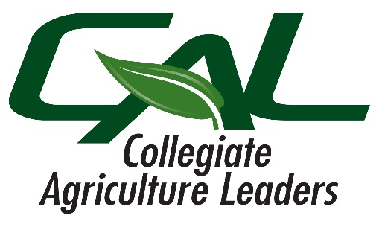

Collegiate Agricultural Leaders
Spring Leadership Competitions
February 9th, 2024 @ Merced College

Schedule:
11:00am Registration / Lunch New AGIT Building - Foyer
12:00pm Welcome & Contest Overview
12:30pm Begin Leadership Competitions
- Discussion Meet
- Prepared Public Speaking
- Extemporaneous Public Speaking
- Ag Sales
- Ag Marketing Plan
- Job Interview:
  - Ag Education
  - Horticulture & Natural Resources
  - Production Agriculture
  - Ag Technician
  - Ag Sales & Service
3:30pm College Bowl Orientation
4:00pm College Bowl (Preliminary & Semi-Final Rounds)
6:00pm Dinner
6:30pm College Bowl Finals
7:00pm Awards

