Agricultural Mechanics
Revised 6/2023
Purpose and Standards
The agricultural mechanics event seeks to effectively prepare the students for the expectations of the agricultural mechanics’ workplace. Workers seeking careers in agricultural mechanics must not only develop a high degree of knowledge and skill they must also develop the ability to solve difficult problems. This event blends the testing of manipulative skills and knowledge required for careers in fabrication and construction. California Career Technical Education Model Curriculum Standards addressed by this event include:

Foundation Standards: Mathematics Algebra, 10,13,15 and Geometry 8,10,11. Technology 4.1, 4.2, 4.6. Problem Solving and Critical Thinking 5.1. Health and Safety 6.2,6.4,6.5. Ethics and Legal Responsibilities 8.3. Leadership and Teamwork 9.1, 9.2, 9.3.

Agricultural Mechanics Pathway Standards: B1.1, B1.2, B2.1-B2.4, B3.1-B3.5, B4.1, B4.3, B4.4, B5.1-B5.5, B6.1-B6.3, B7.1-B7.5, B8.1-B8.4, B9.1-B9.7, B12.1, B12.3, B12.6
Contestants
To be eligible to compete at the state finals contest, a team must compete in a minimum of three qualifying field days. To be a qualifying contest, the contest must adhere to the following criteria:
- Submit the contest date to FFA for inclusion on the calaged.org calendar by October 1.
- 1 team per school has priority before alternates are allowed into contest.
- Agree to submit results of the contest within two weeks following the contest.
- Agree to submit the results in the following manner:
  - Include the complete chapter name
  - Include the Chapter ID number (CA_ _ _ _)
  - Provide a ranking list of only the “A” teams (no “B” teams or alternates)
- Agree to cover the six rotations outlined within this code. With the exception of the State Finals contest, a contest site may modify the rotation structure by splitting a rotation into two or by inserting a “Bye” rotation. In either case, the total points for a rotation area will be 100 points (ie. If a Problem Solving rotation is split into two, the parts added together will equal 100 points).
- In order to become a qualifying contest site, the contest must be run for 1 year as a probationary contest to ensure they can meet eligibility as outlined in #4 above. After one year, coaches that attended the contest can vote to approve the contest to be added to the list. No state staff official will be able to add a new qualifying contest its first year to this list without it first being a probationary contest.
- If a contest site on the approved list does not run a contest for three (3) consecutive years, then that contest site will be dropped from the list and will have to go through the probationary process again to get back on the list.
- The qualifying contest list will be reviewed every three years when the Ag Mechanics contest comes up for it's Curricular Code review, and contest sites may be removed if their contest has not been adhering to the criteria in #4 above.
Only the top 24 teams, determined mathematically, will be eligible to compete at the state finals contest. The formula to calculate the 24 qualifying teams will be:
Weighted Score = (51 – Ranking) + (# of teams – Rank)/2.
Top 24 Tie Breaker: Use the rank of the 4th contest for the tie breaker of the top 24 ranking for the state finals contest. If a tie still exists go to the 5th contest.

Teams consist of four members, with all four individual scores counting as the team score. All team members are eligible for individual awards. A partial team of no less than three contestants may compete and be ranked at any contest leading up to the State Finals contest by including a score of “0” for the fourth score (all four scores make up the team score).

Classes
This contest shall include six rotations:
Class | Individual Points | Team Points
Tools and Materials Identification / Written Test | 100 | 400
Arc Welding Skills | 100 | 400
Problem Solving /Plan Interpretation | 100 | 400
Electrical Skills | 100 | 400
Option Area #1 | 100 | 400
Option Area #2 | 100 | 400
Total (possible per contestant) | 600 | 2400

The option areas shall be selected from the following three groups of contest areas. The Option Groups will alternate on a three-year rotation based on the year that the State Finals contest is in.

Option Group #1 - 2021
Electric Motors & Controls
Plumbing Skills

Option Group #2 - 2022
Cold Metal and Sheet Metal Fabrications Skills
Oxyfuel Welding/Cutting Skills

Option Group #3 - 2023
Leveling and Land Measurement Skills
Woodworking/Carpentry Skills

Tie Breaker
- In the Agricultural Mechanics Contest, individual or team ties will be broken on the basis of the highest individual or team score using the Tool & Material Identification/Written Test score.
- If a tie still exists, the individual or team arc welding score will be used to determine the high individual or team.
- If a tie still exists, the total score of the individual or team will be used to determine the high individual or team.
Sub-contest Awards
Sub-contest awards will be given for high teams and individuals in the following areas:
Tools and Materials Identification/Written Test, Arc Welding Skills, Problem Solving / Plan Interpretation, Electrical Skills, Option Area #1, and Option Area #2.
Host School Requirements
Project plans, scored sheets, and the written test are to be provided as described below:
Rules
- Each qualifying contestant will compete in all six events.
  - At the time of the contest, plans and instructions will be provided to contestants. The time limits on each event will be forty minutes in length plus a five-minute instructional / passing period for a total of forty-five minutes per event. Each contestant will provide and use safety glasses conforming to OSHA standards throughout the contest.
    - Each Contestant (not shared) must have the following equipment:
      - Steel Tape
      - #2 Pencil
      - Combination Square
      - Safety Glasses
      - Calculator
      - Clip board
    - Each Team (4 contestants) will have the following minimum equipment - see Appendix I list.
    - Host school may modify the list by providing changes to list (additions or deletions) 30 days prior.
    - Tools must be safe to operate (ex. guards in place). Unsafe tools may be confiscated for the duration of the contest
  - The sponsoring school has the option to include safe work habits as part of the scorecard. Contestants will be informed at contest lineup that 25 points will be deducted for violations such as, but not limited to, not wearing safety glasses, power tool misuse, not wearing proper gloves while welding, etc. After this point deduction on the scoresheet, the sponsoring school reserves the right to remove any contestant that violates accepted safety practices that endanger him/herself or others in the contest from that particular skill area. The student may continue with the remainder of the contest but will receive no credit/points for the area where the infractions occurred. After a warning, the sponsoring school reserves the right to remove any contestant that violates accepted safety practices that endanger him/herself or others in the contest.
  - The sponsoring school has the option of requiring each school and contestant to sign a liability release as a condition of participating in the contest.
  - The sponsoring school has the option of limiting the use of power tools at their contest as long as participating schools are notified of the limitation at least 30 days prior to the contest.
- No unauthorized notes, printed materials, or tools may be used in Written Test/Tool ID or Problem Solving areas of the contest. Contestants found in violation will be disqualified from contest.
- Portable, cordless, rechargeable, battery powered tools may be used in the contest only as specified in each skill or option area. No means of charging batteries will be provided by the sponsoring school in the event of dead or low batteries.
- Contest Area Descriptions
  - Tool and Material Identification / Written Test. This area will consist of 50 items to identify and 50 questions to answer.
    - Tools and Materials Identification
      - The tools and materials identification event shall consist of the identification of common tools and materials used in agricultural mechanics and limited to those items listed on the California Agricultural Teachers’ Association Website – http://www.calagteachers.org/CurricularActivitiesCode.html.
      - Multiple-choice type questions requiring identification or selection of proper tools or materials or bill of materials may be included.
      - That the Tool ID test use real tools and materials and not pictures for the test.
    - Written Test
      - Shall include questions and/or problems from the following areas:
Areas | Points
General Ag Mechanics & Safety | 5
Arc Welding | 5
Electrical Skills | 5
Electric Motors & Controls | 5
Woodworking/Carpentry Skills | 5
Plumbing Skills | 5
Cold Metal and Sheet Metal Fabrication Skills | 5
Oxyfuel Welding & Cutting Skills | 5
Leveling and Land Measurement Skills | 5
Concrete & Masonry | 5
Total Points Possible | 50

      - The test can be true-false, multiple choice, problems, short answer, or any combination of tests. Questions will be limited to the following reference list:
      - Modern Agricultural Mechanics by Burke and Wakeman, Published by Interstate.
      - Agricultural Mechanics: Fundamentals and Applications by Cooper, Published by Delmar.
      - Electrical Wiring by AAVIM.
      - Leveling and Land Measurement Practices for Agriculture (along with student workbook) Agricultural Education Department, University of Arizona or Hobar Publications.
      - Surveying Reference: Landscape Surveying (2nd Edition), Field, Publisher: Cengage.
      - Plumbing Reference: Principals of Irrigation (3rd Edition), Irrigation Association.
      - These resources are to be the most current editions.
      - A copy of that year’s written test will be provided to coaches as a hard copy or electronically.
  - Arc Welding Skills (SMAW and/or GMAW)
    - GMAW would be an option for the host school. If they choose to have GMAW then the host school will inform the participating school’s coaches.
    - Arc welding may be in the flat, horizontal, vertical or overhead positions or project construction incorporating butt, lap, tee, flange, corner, pipe to plate or pipe to pipe joints using, AC or DC machines. A variety of electrodes will be provided or contestants may bring their own. Contest personnel will be available to familiarize contestants with the welding machine.
    - Clothing - Each contestant shall provide and wear coveralls, a shop coat or uniform for this event. Clothing must be in good repair and fit properly. Long sleeve clothing must be worn when welding or cutting. Clothing must be non-synthetic (e.g., cotton, wool, leather, cotton blend, etc.)
    - Project plans and score sheets will be provided to coaches either as a hard copy or electronically.
    - A cordless angle grinder or drill may be used with a wire cup for cleaning up welds.
  - Problem Solving & Plan Interpretation
    - Contestants would be required to perform calculations and/or answer questions based on a project, a scenario, or a set of plans. Questions must be based on current year six (6) rotations. Examples of possible activities include, but not limited to the following:
      - Answer questions on a set of plans or a given scenario
      - Develop a cut list
      - Develop a bill of materials
      - Make corrections on a set of plans
      - Perform actual measurements on a project
      - Answer questions based on provided code information
  - Electrical Skills
    - Electrical Skills - may include one or more of the following:
      - Teams would provide a standardized electrical board that would be suitable for projects using single conductor or NM cable, a variety of devices, and a number of wiring problems. These boards would be standardized in configuration and size as described below. Teams could use these for practice.
      - Host schools would provide consumable wiring materials (so contestants can take the completed project).
      - Boards would be required for state finals and recommended for other competitions. As with tools, a team not providing the boards and associated supplies for each contestant would be unable to compete.
      - Boards not constructed to specifications outlined in this section may not be scored.
      - Allow for the pre-wiring of ground wires in boxes only.
      - Contestants may provide their own pigtails or NM cable that is no longer than 10” in length.
      - For their part host institutions would create projects that can be built using theses boards or have the option of providing additional devices.
      - Wiring 120 and 240 volt circuits including switches, lights, breaker panel, and outlets according to the instructions given.
      - Allow for the power source to come from any location on the board or from multiple locations.
      - Making splices
      - Identification of safety issues within a system
      - Reading kilowatt hour meters and/or calculating power costs
      - Use of a multi-meter to derive information from circuitry
      - Cordless power screwdrivers (not drills) may be used.
      - Project plans and score sheets will be provided to coaches either as a hard copy or electronically.
California Ag Mechanics CDE Electrical Board
Contest Procedure:
Contestants will provide the regulation board.
Host will provide:
- Wire nuts, grounding crimp sleeves/green wire nuts
- Wire. E.g.; 14 ga. THHN or NM cable
Host will specify the following as part of the contest area instructions:
- Device location
- Wiring circuit description in text (example: Switch will control the lamp, duplex receptacle is always hot), standard electrical plan, or other method.
- Project can use one or more of the boxes.
Materials (per board):
½ CC Plywood board (8 per sheet)
4 – 4” sq. Electrical boxes with ½” KO
2- ½” EMT Box connectors
30” of ½” EMT (3 – 8” long pieces; 2 – 3” long pieces)
5 – Grounding screws installed in the box
5 – ½” NM cable clamps
2 – Duplex Receptacle
1 – 20 amp, 240 Volt Receptacle
2- Lamp holder with pig tails (must be connectable with wire nuts like common light fixtures)
2 – SPST switch
2 – 3 way switches SPDP
1 – 4 way switch DPDT
1 – 20 amp GFCI Duplex Receptacle
1 – 70 amp subpanel with two 20 amp and two 15 amp circuit breakers capable of wiring the following circuits:
- 15 amp, 120 volt
- 20 amp, 120 volt
- 20 amp, 240 volt
(Subpanel must have a separate grounding bus bar and an insulated neutral bus bar)

The following links are to the recommended Sub Panel and Breaker that should be used for the wiring boards:
The Sub Panel:
https://www.homedepot.com/p/Square-D-Homeline-70-Amp-2-Space-4-Circuit-Indoor-Surface-Mount-Main-Lug-Load-Center-with-Cover-HOM24L70SCP/100202333#.Ula_FVBzF8E%20ii.
The Quad-breaker:
https://www.homedepot.com/p/Square-D-Homeline-2-15-Amp-Single-Pole-1-20-Amp-2-Pole-Quad-Tandem-Circuit-Breaker-HOMT1515220CP/100150477#.Ula_vVBzF8E%202.
The load center is manufactured by Square D for the Home Depot “Homeline” brand. The breaker is also made by Square D.
The Sub Panel:
Eaton BR24L70SGP
https://www.platt.com/platt-electric-supply/Load-Centers-Aluminum-Bus-1-Phase-Main-Lug/Eaton/BR24L70SGP/product.aspx?zpid=347203

Quadplex Breaker (15 amp single pole-outer, and 20 amp center common trip)
Eaton BQC2202115
https://www.platt.com/platt-electric-supply/Circuit-Breakers-Residential-Quadplex-Breakers/Eaton/BQC2202115/product.aspx?zpid=354629

Boxes should be centered on the board and placed 8” apart (approximately 12” O.C.). The distance between boxes A and D and the Sub Panel is 3” max.

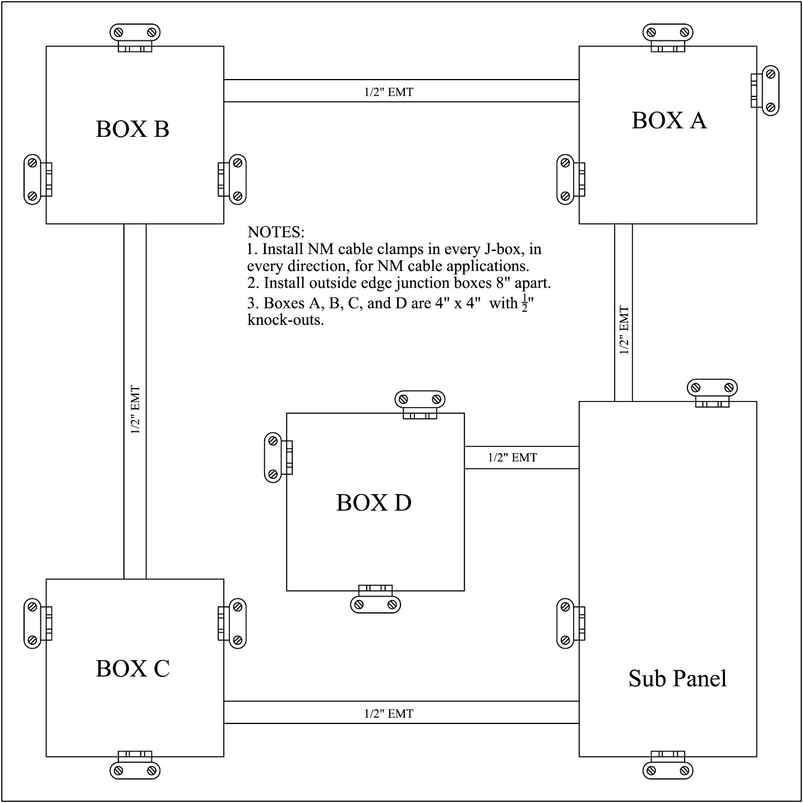

  - Cold Metal and Sheet Metal Fabrication Skills
    - A small project or exercise is to be fabricated using all hand tools except for a power drill for drilling and countersinking. Tools may include:
hacksaws | taps and dies
files | countersinks
drills | layout tools
    - A cordless power drill may be used for drilling. No other power tools are allowed.
    - Project plans and score sheets will be provided to coaches either as a hard copy or electronically.
  - Electric Motors and Controls Skills
    - Knowledge and demonstrated skills to include the following:
      - The reference for this area shall be "Electric Motors: Principles, Controls, Service and Maintenance" by Bear and Hoerner through Hobar Publications and shall be limited to the following chapters and pages:
        - Unit II External Features of Motors
        - Unit III Nameplate Information
          - Electrical features
          - Physical features
          - Manufacturer’s designations
      - Unit V Motors Classification and Operation
      - Unit VI Starting Systems and Circuits
      - Unit VII Changing Voltage, Reversing Rotation and Changing Motor Speed
      - Unit X Electrical Service and Control Devices
      - The skills to be tested shall be set up at the stations where the contestant shall be required to perform a skill relating to this area. Some examples are listed below:
      - Read and interpret a motor nameplate to derive the requested information.
      - Using dial caliper and chart, determining frame designations, shaft size, keyway size, etc.
      - Using the multi-meter, locate start windings and run windings in a disassembled motor.
      - Identify various starting mechanisms e.g. centrifugal switches, starting poles, etc.
      - Identify various control devices such as:
Relays (SPST, SPDT, DPDT, etc.)
Humidistats, thermostats, photo-electric switches, pressure switches, etc.
      - Locate the normally open and normally closed terminals of a controller.
      - Demonstrate how to change rotation and/or voltage on either a single phase or a three-phase motor.
      - Demonstrate how to wire in controls such as a relay to control a light.
      - Project plans and score sheets will be provided to coaches either as a hard copy or electronically.
  - Oxyfuel Welding/Cutting Skills
    - Demonstrated skills to be limited to:
      - fusion welding with steel filler rod on 14 gage or thinner metal
      - bronze welding or brazing
      - flame cutting on material not to exceed 1/2 inch nor thinner than 3/16 inch
    - Project plans and score sheets will be provided to coaches either as a hard copy or electronically.
    - The use of cordless power tools is not allowed.
  - Plumbing Skills
    - Kinds of plumbing materials:
      - steel
      - copper
      - PVC only
      - polyethylene
    - Pipe layout calculating pipe length.
    - Measure, mark, cut, ream and assemble materials and parts.
    - Types of fastening methods:
      - Thread
      - Solder
      - glue
      - flare
      - push in
    - The exercise could be subject to a pressure test.
    - Project plans and score sheets will be provided to coaches either as a hard copy or electronically.
    - The use of cordless power tools is not allowed.
    - Plumbing Reference: Principals of Irrigation (3rd Edition), Irrigation Association.
  - Leveling and Land Measurement Skills
    - Exercises to be limited to:
      - differential leveling
        - setting up a surveying instrument
        - turning points
        - differences in elevation
      - profile leveling
        - setting up a surveying instrument
        - profile leveling grids or lines
        - cut/fill exercises
      - land measurement
        - pacing and linear calculations
        - legal land description
        - reading aerial view maps
        - contour line layout/interpretation
        - land area calculations
      - GPS
        - Marking waypoints or entering from coordinate data.
        - Navigation to waypoints or areas
        - Knowledge of common coordinate systems such as Lat/Lon
        - and UTM
        - Determining distance between waypoints.
        - Plotting of UTM data on a graph or map to mark location or
        - compute area.
        - General GPS knowledge (e.g. specs, how it works).
    - The use of cordless power tools is not allowed.
    - Project plans and score sheets will be provided to coaches either as a hard copy or electronically.
    - Surveying Reference: Landscape Surveying (2nd Edition), Field, Publisher: Cengage.
  - Woodworking/Carpentry Skills
    - Demonstrate fundamental skills in the use of common woodworking tools by making a simple project or solving a woodworking/carpentry problem. The scoring in this area will emphasize the contestant's ability to layout and cut component parts rather than on completion alone.
    - Project plans and score sheets will be provided to coaches either as a hard copy or electronically.
    - Only the following cordless power tools are allowed:
      - Drill
      - Drill driver
      - Jig saw
      - Sander
      - Compound miter saw
Appendix I - Ag Mechanics Contest - Minimum Equipment List

Written Test/Tool I.D.
Clipboard
Problem Solving
Ruler or Scale
Caliper (inside and outside) 4” Capacity
Surveying and Land Measurement
Clipboard
Ruler or scale
Arc Welding Skills
Long Sleeve Welding Jacket (cotton or non- flammable material)
Welding Helmet (shade 10)
Leather Welding Gloves
Chipping Hammer
Pliers
Wire Brush
Mig Pliers (long nose with cutter)
1/8” Electrode (E6010, E6011, E6013, E7018)
Combination Square
Welding Clamps
Soapstone
Electrical Wiring/Motors & Control Skills
Diagonal Cutters
Screwdrivers (Phillips and Standard)
Linesman Pliers
Long nose Pliers
Wire Strippers
Cable Rippers or NM Cable Stripper for #14 NM cable)
Crimping Tool for Bonding Grounding Crimp Sleeves
¼” & 5/16” Nut Drivers
Multi-Meter
Electrical Board and Accessories (See Code)
Plumbing Skills
Steel Pipe Cutter
Steel Pipe Reamer
½” NPT Pipe Die and Pipe Die Stock
Pipe Wrenches (2)
Thread Sealing Materials
PVC Cutter (to 1”)
Hacksaw
PVC Primer and Cement (small brush)
Propane Torch
Non-lead Solder (for potable water)
Flux
Flux Brush
Copper Pipe Brushes (1/2”), Emery Cloth, or Course Steel Wool
Tubing Cutter (1/2” capacity)
Flaring Tools (5/8” capacity)
Adjustable End Wrench (2)
Water Pump Pliers
Portable Pipe Vise
Clean Up Rags
Oxyfuel Skills
Welding Goggles (shade 5) (must fit over safety glasses)
Chipping Hammer
Pliers
Wire Brush
Tip Cleaner
Leather Welding Gloves
Steel Welding Rod
Brazing Rod & flux
Combination Square
Means to Mark Metal (soapstone, scribe, etc.)
Welding Clamps (2)
Woodworking/Carpentry Skills
Combination Square
Carpenters’ / Framing Square
Sliding Tee Bevel
Crosscut Saw or Back Saw
Phillips Screwdriver & Standard Screwdriver
Claw Hammer
Assorted Rasps (with handles)
Finishing Supplies (sandpaper (eg. 120 grit), blocks, etc.)
Cordless Drill (3/8”)
Spade Bits ¼” -1”
Twist Drills Fractional to 3/8”
Adjustable Wrench
Nail Sets
Wood Chisel Set (to 1”)
Mallet
Protractor
Miter Box or Similar Tool
Counter Sink Bit
Tools for Clamping Material to Sawhorse or Workstation
Cold and Sheet Metal Fabrication
Tape Measure
Combination Square
Scribe or Scratch Awl
Cordless Drill (3/8”)
Fractional Twist Drills to 3/8”
Tap and Die Set 1/4” to 3/8” NC and NF
Cutting Oil
Divider (6”)
82º Countersink
Cordless Drill
Hacksaw (extra blades suggested)
Center Punch
Ball Peen Hammer
Pop Rivet Tool Capable of “Popping” 1/8 – 3/16” Diameter op rivets
File Assortment
Tools for Clamping Material to a Work Table
Straight Snips

