Forestry
Revised 04/2024
Purpose
The purpose of this contest is to stimulate student interest and to promote forestry instruction in the agricultural education curriculum and to provide recognition for those who have demonstrated skills and competencies as a result of forestry instruction.
Contestants
Teams consist of four members, with all four individual scores plus the compass activity team event score counting as the team score. All team members are eligible for individual awards. Individuals not on a complete team may also compete for individual awards.

State Finals will consist of two rounds. Round one will be the team event and knowledge portions and round two the remaining portions of the contest. Round one will be held Friday and round two will be held the following day.
Classes
The contest will consist of five divisions involving eight subject areas. A summary of these Skillsets are as follows:
Area | Description | Time | Individual Points | Team Points
Identification – Skillset I (150 points possible)
AREA 1 | Plant Identification | 30 | 100 | 400
AREA 2 | Identification of Forestry Equipment, Wood Species, and Wood Characteristics | 30 | 50 | 200
Land Measurement – Skillset II (100 points possible)
AREA 3 | Acreage | 30 | 30 | 120
AREA 4 | Compass | 30 | 20 | 80
 | Map Reading | 30 | 50 | 200
Forestry Knowledge and Table Interpretation – Skillset III (100 points possible)
AREA 5 | Forestry Knowledge | 30 | 50 | 200
AREA 6 | Graph and Table Interpretation | 30 | 50 | 200
Timber Measurements - Skillset IV (100 points possible)
AREA 7 | Tree Height | 20 | 30 | 120
 | Diameter | 20 | 40 | 160
 | Log Scaling | 20 | 30 | 120
Team Event – Skillset V (60 points possible - team score only)
AREA 8 | Basal Area | 30 |  | 100
TOTAL |  |  | 450 | 1900
Tie Breaker
- In the case of ties, Plant Identification scores shall be used to break the tie.
- If a tie continues to exist, it shall be broken by using the next area of the contest until the tie is broken.
Sub-contest Awards
Sub-contest awards will be given for high teams and individuals in the following areas: Identification – Skillset I, Land Measurement – Skillset II, Forestry Knowledge, and Table Interpretation – Skillset III, Timber Measurements – Skillset IV, Team Event – Skillset V (team only).
Host School Requirements
All equipment for the contestants will be available at the judging sites. Teams should be informed by email at the conclusion of the “on time registration date” with regards to the tools that they are expected to bring. Answer keys will be created by using the same tool that contestants are required to use. For example, the merritt hypsometer will be used to determine the number of logs for given answer key.
Rules
- Contestants in the Forestry Contest will be divided into four groups so that only one member of a school or team will be in the same group at the same time (disqualification will result if this rule is broken). Only one group will be allowed at an area or site at one time.
- All ID including plants, tools, and wood; and knowledge will be presented in a scantron format.
- All adjustable tools and equipment provided by the host school will be calibrated so that the students will have the same opportunity to get the correct answer.
- All contestants must fill out the official scorecard and will be graded according to the points shown on the scorecard.
- Calculators shall be allowed in all aspects of the contest. If a contestant is found using a programmable calculator, they are to be disqualified.
- Contestants are encouraged to use their own measuring tapes (both logging and diameter tapes), non-adjustable measuring equipment, and surveying pins.
- Identification (Skillset I)
  - AREA 1 Plant Identification (Appendix A)
    - Fifty specimens from the Plants Identification list in Appendix A will be displayed.
    - Fresh foliage is preferred and if fruit, flowers, or cones are available they will be part of the identification specimen. Otherwise, cones, fruit or flower, and stems shall be used with a pressed specimen (no more than five pressed items are allowed).
    - The list in Appendix A and the score card shall list plants by scientific name, in alphabetical order, with common names listed on the right.
    - Fruit and/or cones can be displayed by themselves if they are underlined in the plant list (not to exceed five fruits and/or cones on the contest).
    - If contestants are not permitted to touch plants samples; needled plants should have a typical group displayed by taping to a 3x5 card next to the sample so needle length and other features can be observed.
    - Students are permitted to use a ruler.
    - Scoring Information
      - Time allowed: 30 minutes.
      - Total points for this event: 100.
    - Scoring: 2 points for each correctly identified plant species.
  - AREA 2 Identification of Forestry Equipment (Appendix B), Wood Species and Wood Characteristics (Appendix C)
    - Forestry Equipment Identification
      - 25 tools or forestry equipment items from the Forestry Equipment Identification list in Appendix B will be displayed.
      - No more than three (3) Stihl Chain Saw parts will be used.
      - All items will be clearly marked with a reference number for identification.
      - Pictures or accurate models can be used for heavy equipment portion.
      - Items must be good specimens of the equipment.

    - Wood Species Identification
      - 5 wood samples from the Wood Species Identification list in Appendix C will be displayed.
      - Contestants will identify wood samples as to wood type (species).
      - Wood species samples will be typical of market lumber with all 3 wood surfaces shown (tangential, cross section and radial).
    - Wood Characteristics Identification
      - Wood samples showing 10 at 2 points each from the Wood Characteristics List.
      - Characteristics Identification list in Appendix C will be displayed.
      - Natural or manufactured wood characteristics are to be identified. Each sample will be clearly marked.
      - Characteristics will be indicated on the sample as follows:
        - Knot shape will be marked on the sample if round knot or spike knot are wanted.
        - Knot quality will be marked on the sample if encased knot, intergrown knot or knot cluster is to be identified.
        - Grain will be marked on the sample to indicate that flat grain or vertical grain is to be identified.
        - Wood surface will be marked on the sample to indicate that cross-section, tangential surface or radial surface is to be identified.
        - Wood area will be marked on the sample if heartwood, pith, or sapwood is to be identified.
        - All other characteristics will be plainly marked as to what is being asked for by circles, arrows, etc., and the characteristic should be the predominant characteristic on the sample.
    - Scoring Information
      - Time allowed: 30 minutes.
      - Total points for this event: 50.
      - Scoring: One (1) point for each correctly identified forestry equipment item (25), wood species (5), and wood characteristic (20).
- Land Measurement (Skillset II)
  - AREA 3 Acreage
    - A three to four-sided polygon with straight sides shall be measured for area in acres.
    - It will be free of obstructions so that it can be easily paced.
    - The acreage problem given must be 0.30 to 1.25 acres in area.
    - Scoring Information
      - Time allowed: 30 minutes.
      - Total points for this event: 30.
      - Scoring: One (1) point will be deducted for each .01 acres of error
  - AREA 4 Compass and Map Reading
    - Compass Reading
      - The contestant will be provided with a bearing hand compass that has been set at a magnetic declination of zero and checked for accuracy prior to each contest.
      - A polygon of 4 stations in the form of a traverse will be laid out in the field. Each forward station will be visible from each back station. The beginning and ending point will be Station A.
      - The contestant will start at Station A and determine the bearing to Station B. Contestant will move to the next station and determine the bearing to the forward station, continuing this procedure until finally determining the fourth bearing while sighting Station A. A total of 4 bearings will be determined. The contestant will record the answers on the form provided.
      - Scoring Information
        - Time allowed: 30 minutes.
        - Total points for this event: 20.
        - Scoring: Five (5) points possible for each correct bearing. One (1) point deducted for each two (2) degrees of error.
    - Map Reading
      - Contestants will be provided with a U.S. Geological Survey map such as the 7.5 minutes series map.
      - Specific points will be marked for the contestant to identify.
      - The contestant is expected to: know legal land description, recognize topographic map symbols, understand the meaning of map symbols, use the scale to correctly determine distance between points, calculate the number of acres in a parcel, and determine elevations.
      - Example questions:
        - What is the legal land description of the five parcels marked?
        - What is the item located at this point?
        - What is the acreage of the area enclosed?
        - What is the distance in miles from point A to point B?
        - What is the elevation (on the contour line) at point C?
      - Five specific parcels will be indicated and numbered on a map and the student will determine the proper legal description.
      - The following parcels can be determined:
        - 1/4 of a section
        - 1/4 of a 1/4 section
        - 1/2 of a section
        - 1/2 of a 1/4 section
      - The legal description will be written as follows: NW 1/4, SE 1/4, Sec. 23, T4N, R2E, MDM. Abbreviations will be used as above except that section can also be written as S. (as on national contest). Commas can be replaced by the word of.
    - A Dot Grid may be used to determine acreage using either the 660 or 440 scale dot grid. The student will be provided with a dot grid and a map scale. Full point value will be awarded if calculations are within 10% of the total correct acreage.
    - Scoring Information
      - Time allowed: 30 minutes.
      - Total points for this event: 50.
      - Scoring:
        - Each correct parcel legal description is worth five points. Five parcels x 5 points each = 25 points. Partial credit will be allowed. For example, each error will have a deduction of one point. If NW 1/4 is correct and SW 1/4 is the answer one point will be deducted. Other examples: incorrect Sec., etc., is one point de-ducted. Maximum of five points deducted per parcel.
        - Additional questions will be worth a total of 25 points.

- Forestry Knowledge and Graph and Table Interpretation (Skillset III)
  - AREA 5 Forestry Knowledge:
    - 25 questions from the Forestry Knowledge list in Appendix D will be selected.
    - Scoring Information
      - Time allowed: 30 minutes.
      - Total points for this event: 50.
      - Scoring: A total of 25 questions will be selected. Each question is worth two points each.
  - AREA 6 Graph and Table Interpretation: 50 points total.
    - Site Index
      - A site index graph will be selected from those presented in Appendix E.
      - Three sets of tree heights and tree ages will be given.
      - The average tree height and age will be calculated by the contestant.
      - The site index will be calculated by the contestant from their calculated averages and the graph provided. The site index will be scored correct within a range of plus or minus 2 site index reference numbers.
      - Scoring Information
        - Time allowed: 30 minutes total for both (a) site index, and, (b) board foot volume.
        - Total points for site index: 20. Scoring will be based on the actual value plotted (not rounded to the nearest line).
        - Scoring: Ten points will be given for the correct Site Index rating, five points will be given for the correct average height, and five points will be given for the correct average age.
    - Board foot volume
      - The dbh and height for three trees will be given.
      - Board foot volume will be determined using a volume table in units of board foot volume.
      - Scoring Information
        - Time allowed: 30 minutes total for both (a) site index, and, (b) board foot volume.
        - Total points for this event: 30.
        - Scoring: Ten points will be awarded for each correct total volume (one point deducted for each ten board feet off).
- Timber Measurements (Skillset IV)
  - AREA 7 Timber Measurement
    - Tree Height
      - Contestants will measure tree heights on two trees to the very top of the tree.
    - The clinometer will be used on one tree for total height, and either a logger’s tape or a one hundred (100) foot tape will be used for measuring distance from the tree. Answers will be given in feet.
    - The Merritt Hypsometer will be used on one tree for number logs, and either a logger’s tape or a one hundred (100) foot tape will be used for measuring distance from the tree. Answers will be given in logs and ½ logs. When reading the hypsometer; answers will always be rounded down to the nearest half logs.
    - Scoring Information
      - Time allowed: 10 minutes.
      - Total points for this event: 30.
      - Scoring: 15 points per tree possible. One (1) point will be deducted for every foot of error using a Clinometer. Five (5) points will be deducted for every 1/2 log (8 feet) of error using a Merritt Hypsometer.
    - Tree Diameter
      - Contestants will measure four (4) trees for diameters. Diameter will be determined at dbh (4.5 ft.).
      - Trees A & B will be measured with a Biltmore Stick
      - Trees C & D will be measured with a diameter tape to the nearest 0.1 in.
      - Scoring Information
        - Time allowed: 10 minutes.
        - Total points for this event: 40.
        - Scoring: Ten points will be scored for each diameter. One point will be deducted for each two (2) inches of error for trees measured with a Biltmore Stick. One point will be deducted for each 0.1 inch of error for the trees measured with a diameter tape.
    - Log Scaling (Appendix F)
      - A Scribner’s Decimal C log scaling stick will be used.
      - The answer will be given in board feet. A log defect may be indicated and will be identified by its volume in either board feet or in Scribner’s Decimal C.
      - No odd length logs will be used. If rounds are used for diameters, two rounds should be used, one for the small end and one for the large end. The log length will be given in even footage. Length rules are included in Appendix F. Rules for butt logs are also provided in Appendix F. If the contest is giving butt logs, this needs to be indicated on the log or score sheet clearly to the contestant.
      - Scoring Information
        - Time allowed: 10 minutes.
        - Total points for this event: 30.
        - Scoring: Two logs will be measured at 15 points each. One point will be deducted for each 10 bd. ft. of error.
- Team Event (Skillset V) – Three team events will be used on a rotating basis.
    - 2023 Compass and Tape
    - 2024 Basal Area
    - 2025 Timber Cruising
    - 2026 Compass and Tape
    - 2027 Basal Area
    - 2028 Timber Cruising

  - Compass and Tape Measurement – Team Event
    - The four (4) team members will be given data for a four-sided traverse.
    - Compass bearings will be to the nearest one (1) degree.
    - The traverse will be set up by the judge with a staff compass, transit or an advanced technique that is superior to a transit. If the course is laid out with a compass, bearings will be true bearings and the compass used will be adjusted for declination.
    - Contestants will be supplied with a Silva Bearing compass and a 100 foot tape. All hand compasses will be set to 0 declination.
    - Answers will be given as a measured distance from the contestant’s ending point to the traverse beginning point. The answer will be compared to a known distance from the traverse ending point to the beginning point.
    - The traverse ending point will be located at least 25 feet from the beginning point.
    - Scoring Information
      - Time allowed: 30 minutes.
      - Total points for this event: 60.
      - Scoring: One (1) point will be deducted for every one (1) foot error.
  - Basal Area – Team Event
    - A wedge prism of 10 factor will be used at the contest site and will be designated prior to the contest. It is encouraged to have at least one borderline tree in the plot.
    - Scoring Information
      - Total points for this event: 60.
      - Scoring: Two (2) points will be deducted for each one square foot of error.
      - The answer for Basal Area must be reported in square feet per acre.
  - Timber Cruising - Team Event
    - A cruisers stick will be used to determine the number of logs and diameter class of ten trees. Using the provided Scale table (Appendix H) students will determine the total scale and report their data on the provided table (Appendix G). Contestants will use board foot volume to determine a dollar value of the stand in dollars per thousand board feet (using the given rate of $452/thousand board feet).
    - Contest sights may elect to use fewer trees if ten are not available by providing data (logs and diameter class to plug into the table).
    - Scoring Information
      - A correct answer will fall within $226 of the determined dollar value amount. Teams will be penalized by five (5) points per each $226 (half of given value/thousand) that their answer is off.

Appendices
A – Plant Identification List
B – Forestry Equipment Identification List
C – Wood Identification Species and Characteristics List
D – Forestry Knowledge List
E – Site Index Graphs
F – Log Scaling Lengths and Rules for Butt Logs
G – Cruising Table
H – Volume Table
I – Basal Area
J – References
Appendix A -- Plant Identification List

 | 1 | Abies concolor | White fir
 | 2 | Abies magnifica | Red Fir
 | 3 | Abies grandis | Grand Fir
 | 4 | Acer negundo | Box-elder
 | 5 | Acer macrophyllum | Big-leaf Maple
 | 6 | Adenostoma fasciculatum | Chamise
 | 7 | Aesculus californica | California Buckeye
 | 8 | Alnus rhombifolia | White Alder
 | 9 | Alnus rubra | Red Alder
 | 10 | Arbutus menziesii | Pacifica Madrone
 | 11 | Arctostaphylos spp. | Manzanita (California Native)
 | 12 | Baccharis pilularis | Coyote Bush
 | 13 | Berberis aquifolium | Oregon Grape
 | 14 | Betula occidentalis | Water Birch
 | 15 | Calocedrus decurrens | Incense Cedar
 | 16 | Ceanothus cuneatus | Buckbush
 | 17 | Ceanothus interrimus | Deerbrush
 | 18 | Ceanothus leucodermis | Chaparral Whitethorn
 | 19 | Cercis occidentalis | Western Redbud
 | 20 | Cerocarpus betuloides | Mountain Mahogany
 | 21 | Chamaebatia foliolosa | Sierra Mountain Misery
 | 22 | Chamaecyparis lawsoniana | Port Orford-Cedar
 | 23 | Chrysolepis chryophylla | Golden Chinkapin
 | 24 | Cornus nuttallii | Pacific Dogwood
 | 25 | Diplacus spp. | Monkey Flower (California Native, shrub)
 | 26 | Eriodoctyon spp. | Yerba Santa
 | 27 | Fraxinus latifolia | Oregon Ash
 | 28 | Fremontodendron californica | Flannel Bush
 | 29 | Hesperocyparis macrocarpa | Monterey Cypress
 | 30 | Heteromeles arbutifolia | Toyon
 | 31 | Jugalans californica | California Black Walnut
 | 32 | Juniperus californica | California Juniper
 | 33 | Lupinus albifrons or arboreus | Bush Lupine or Tree Lupine
 | 34 | Natholithocarpus densiflorus | Tan Oak Tanbark Oak
 | 35 | Picea sitchensis | Sitka Spruce
 | 36 | Pinus attenuata | Knobcone Pine
 | 37 | Pinus contorta | Lodgepole Pine
 | 38 | Pinus coulteri | Coulter Pine
 | 39 | Pinus jeffreyi | Jeffrey Pine
 | 40 | Pinus lambertiana | Sugar Pine
 | 41 | Pinus monophylla | Singleleaf Pinyon Pine
 | 42 | Pinus monticola | Western White Pine
 | 43 | Pinus muricata | Bishop Pine
 | 44 | Pinus ponderosa | Ponderosa Yellow Pine
 | 45 | Pinus radiata | Monterey Pine
 | 46 | Pinus sabiniana | Foothill Pine Grey Pine
 | 47 | Pinus torreyana | Torrey Pine
 | 48 | Platanus racemosa | California Sycamore
 | 49 | Populus fremontii | Fremont Cottonwood
 | 50 | Populus trichocarpa | Black Cottonwood
 | 51 | Populas tremulodies | Quaking Aspen
 | 52 | Pseudotsuga menziessii | Douglas Fir
 | 53 | Pteridium aquilinium | Bracken Fern
 | 54 | Quercus agrifolia | Coastal Live Oak
 | 55 | Quercus chrysolepsis | Canyon Live Oak
 | 56 | Quercus douglasii | Blue Oak
 | 57 | Quercus kelloggii | California Black Oak
 | 58 | Quercus lobata | Valley Oak
 | 59 | Quercus wilezinii | Interior Live Oak
 | 60 | Rhamnus spp. | Coffee Berry
 | 61 | Rhododendron occidentiale | Western Azalea
 | 62 | Ribes spp. | Current or Gooseberry (California Native)
 | 63 | Rosea spp. | Rose (California Native)
 | 64 | Rubus parviflorus | Thimbleberry
 | 65 | Salix spp. | Willow (California Native)
 | 66 | Sambucus mexicana | Blue Elderberry
 | 67 | Sequoiadendron giganteum | Giant Sequoia
 | 68 | Sequoia sempervirens | Coast Redwood
 | 69 | Taxus brevifolia | Western Yew
 | 70 | Thuja plicata | Western Red Cedar
 | 71 | Torreya californica | California Nutmeg
 | 72 | Tsuga spp. | Mountain Hemlock or Western Hemlock
 | 73 | Umbellularia californica | California Bay Laurel
 | 74 | Woodwardia fimbriata | Giant Chain Fern

*Fruits and/or cones may be displayed by themselves from the plants that are underlined.

Appendix B – Forestry Tools & Equipment Identification List
1 | Abney Level | 38 | Engineer’s Tape
2 | Altimeter | 39 | Fire Rake
3 | Anemometer | 40 | Fixed Radius Plot Tape
4 | Axe – Cruiser’s | 41 | Flagging Tape
5 | Axe – Double Bit | 42 | Forester’s Hand Compass
6 | Axe – Hand | 43 | Fusee
7 | Axe – Single Bit | 44 | GPS – Hand Held
8 | Bark Gauge | 45 | Hazel Tool
9 | Back Pump | 46 | Hoedad
10 | Brand Hammer | 47 | Hookeroon
Chain Saw Parts Identification |  | 48 | Increment Borer
11 | Chain Saw Chain | 49 | Jacob’s Staff
12 | Chain Saw File | 50 | Leveling Rod
13 | Guide Bar | 51 | Logger’s Tape
14 | Oil Filler Cap | 52 | McLeod
15 | Starter Grip | 53 | Peavy
16 | Ignition Switch | 54 | Plumb Bob
17 | Spark Plug | 55 | Pulaski
18 | Throttle Lever Lock | 56 | Range Finder
19 | Spark Plug Wire | 57 | Relaskop
20 | Air Filter | 58 | Safety Hard Hat
21 | Brake Lever | 59 | Scaling Stick
22 | Fuel Filler Cap | 60 | Shovel
23 | Choker Lever | 61 | Sledge (or Single Jack)
24 | Throttle Trigger | 62 | Sling Psychrometer
25 | Chaps A | 63 | Soil Tube
26 | Choker B | 64 | Splitting Maul
27 | Clinometer | 65 | Staff Compass
28 | Cross cut Saw | 66 | Stereoscope
29 | Cruiser’s Stick | 67 | Surveying Pins
30 | Data Recorder | 68 | Talley Sheet
31 | Diameter Tape | 69 | Tree Caliper
32 | Dot Grid | 70 | Tree Injector
33 | Drip Torch | 71 | Tree Marking Gun
34 | Dibble Bar | 72 | Tree Planting Bag
35 | Dixie Pike Pole | 73 | Tree or Pole Climbers
36 | Dumpy Level | 74 | Wedge Prism
37 | Ear Protectors | 75 | Wedge – Falling
 |  | 76 | Wedge - Splitting

Forestry Heavy Equipment
77 | Skidder | 81 | Yarder
78 | Feller-Buncher | 82 | Self Loading Log Truck
79 | Dozer | 83 | Rubber Tire Loader
80 | Logging Helicopter | 84 | Processor

Appendix C – Wood Identification Species and Characteristics List
Wood Identification Species List

1 | Alder | 7 | Ponderosa Pine
2 | Black Walnut | 8 | Sugar Pine
3 | Coast Redwood | 9 | Western Red Cedar
4 | Douglas-Fir | 10 | White Ash
5 | Incense-Cedar | 11 | White Fir
6 | Maple | 12 | Oak Species

Wood Identification Characteristics

Area: |  | Other:
13 | Heartwood | 25 | Birdseye
14 | Pith | 26 | Flecks
15 | Sapwood | 27 | Grub Holes
Grain: |  | 28 | Pitch Pocket
16 | Flat Grain | 29 | Planer Miss or Skip
17 | Vertical Grain | 30 | Season Check
Knot Quality: |  | 31 | Shake
18 | Encased Knot | 32 | Split
19 | Intergrown Knot | 33 | Stain
Knot Shape: |  | 34 | Timber Break
20 | Round Knot | 35 | Unsound Wood (Rot)
21 | Spike Knot | 36 | Wane
Wood Surface: |  | 37 | Warp
22 | Cross Section | 38 | White Speck
23 | Radial
24 | Tangential

Appendix D -- Forestry Knowledge List

Forestry knowledge questions will be derived from this list.

No. | Term | Description
A | Acre | Ten square chains, or 208.7 ft. by 208.7 ft. square, or 43,560 square ft.
B | Afforestation | Establishment of a forest or stand in an area not previously forested.
C | Age-Class | Classification of a stand of trees based on when regeneration started.
D | Rotation-Age | Age at which a tree is ready to harvest.
E | Annual Ring | A summer and spring ring representing one growth year.
A | All-Aged | A stand of timber where all age classes are represented.
B | Aspect | Direction the slope faces.
C | Azimuth | Three hundred sixty (360) degrees on compass.
D | Back-Fire | Fire set along a control line which burns back into the fire.
E | Inner Bark | Area between the cambium and periderm.
A | Outer Bark | Layer of tissue outside of the last periderm layer.
B | Bearing Compass | A compass set up with four (4) 90 degree quadrants.
C | Tree Biomass | Weight of complete trees (living material).
D | Board Foot | The volume equivalent to a board one inch thick x twelve inches wide x twelve inches long.
E | Bole | Trunk or stem of a tree.
A | Breast Height | A point on a tree 4.5 ft. above the ground on the uphill side of a tree.
B | Controlled Burning | A deliberately started fire to accomplish a particular management purpose.
C | Burning Prescription | Describes the conditions and results to be garnered from a control burn.
D | Buck | To cut logs into specific lengths.
E | Butt Log | The first log above the stump.
A | Cambium | Growing tissue, produces xylem and phloem, that is part of the inner bark.
B | Chain | 66 ft. measurement unit, or four (4) rods long.
C | Chaparral | A thicket of low, evergreen oaks or dense tangled brushwood.
D | Season Check | Lengthwise separation of wood which goes or extends across the rings of annual growth and is caused by stress during seasoning.
E | Clearcutting | Area in which the entire timber stand has been cut.
A | Codominant | Trees which are the average level of the canopy and receive light on the top but not necessarily on all sides of the crown.
B | Conifer | Cone bearing trees, usually evergreen.
C | Cord | Unit of measurement for stocked wood, four ft. by four ft. by 8 ft. (4’ x 4’ x 8’) or 128 cubic feet.
D | Crown | The part of a tree or woody plant bearing live branches and foliage.
E | Crown Fire | Fire which has moved into the tops of the trees.
A | Cruise | Survey of forest lands to locate and estimate volume and grades of standing timber.
B | Cubic foot | A unit of true volume that measures 1 x 1 x 1 ft or the equivalent of 12 board feet.
C | Cunit | A unit of volume, usually pulpwood, that measures 100 ft³.
D | Cull | Any item of production, e.g., trees, logs, lumber, or seedlings, rejected because it does not meet certain specifications of usability or grade.
E | Deciduous | Trees which usually drop all of their leaves more or less at one time, usually in the fall.
A | Mill Deck | Platform where logs are held in the sawmill prior to sawing.
B | Log Defect | Any irregularity or imperfection in a log which reduces the volume of sound wood or lowers the durability, strength or utility value.
C | Dendrology | Identification or systematic classification of trees.
D | Crown Density | The compactness of foliage of the crowns of trees and shrubs.
E | Dioecious | Male and female flowers produced on separate plants.
A | Dominant | Trees whose crowns extend above the average level of the forest canopy. They receive direct sunlight from above and some from the sides.
B | Duff | Organic debris in various stages of decomposition on top of the mineral soil.
C | Ecology | The study of the interrelationships between living organisms and the environment.
D | Even-Aged Management | Applied to a stand where relatively small age differences exist between individual trees. The maximum age difference is usually 10 to 20 years.
E | Tree Farm | Area usually privately owned which is dedicated to the production of timber products.
A | Surface Fire | A fire which burns over the forest floor and burns only the surface litter, loose debris and small vegetation.
B | Exploitation | Use of natural resources with economic greed as the primary motivation and the manipulation of the environment with no consideration for sustained yield.
C | Firebreak | A barrier existing or constructed before a fire to serve as a line from which work can be facilitated. Inflammable materials have been removed from the area and it is designed to stop creeping or running fires.
D | Multiple Use of the Forest | Management of the forest with concern for all natural resources including timber, wildlife, recreation, mining, watershed, and range. All of the uses are used without the harming or detrimental affects on the other uses.
E | Gall | A pronounced localized swelling of modified structure which occurs on plants usually as the result of the irritation or stimulus by another organism.
A | Girdle | To completely encircle the bole of a tree with cuts that completely sever the cambium layer eventually killing the tree.
B | Ground Fire | A fire which burns in the organic matter and down into the soil and roots.
C | Habitat | The site or area in which the plants or animals live. The unit area of the environment synonymous with site.
D | Hardwood | Wood produced by broadleaf trees; same as porous wood.
E | Heartwood | The inner core of the woody stem or bole wholly composed of nonliving cells and usually has a darker color.
A | Hectare | A unit of land measure within the metric system. About 2.471 acres.
B | Heeling In | Placing small bundles of bare-root seedlings in a shallow trench or hole and covering the roots.
C | Herbicide | A chemical used for killing or controlling the growth of plants.
D | Humus | Plant and animal residues of the duff which is in varying stages of decomposition.
E | Hypsometer | Instrument used to measure tree height using geometric or trigonometric principles.
A | Intermediate Cuts | Harvest of trees made before a final harvest.
B | Intolerance | Inability of a tree to develop and grow in shade or in competition with other trees.
C | Kerf | Saw width of cut made by the saw. Basically sawdust residue.
D | Litter | Organic materials on upper layer of the duff.
E | Log | a) To cut and deliver logs aka logging.
A |  | b) Tree segments, cut to length and suitable for lumber.
B | Lookout | A station used for detection of fires. Usually a tower at a high point so a good view of the forest is available.
C | Lop | To cut limbs from trees, whether standing, felled, or fallen.
D | Maturity | Age beyond which growth declines in a given species.
E | Mensuration | Science of measurement of volume and growth and development of individual trees and stands and of the products they produce.
A | Merchantable Log | Size of a log, usually 16 ft., which is marketable.
B | Mixed Stand | Less than 75% of the stems in the stand are of the same species.
C | Monoecious | Having male and female flowers on the same plant.
D | Overrun | Excess amount of lumber actually sawed from the logs compared to the estimated volume from scaling.
E | Overstory | Upper crown cover.
A | Pathology | Study of the science of diseases of forest trees or stands, and the deterioration of the products by the organisms.
B | Phloem | Inner bark, just outward of the cambium, that translocates food made in the leaves down to the branches, twigs and roots.
C | Photosynthesis | Process by which plants manufacture food and oxygen.
D | Pole (size class) | Name for trees less than 12 inch dbh. Young: dbh of 4 inches. Small: 4 to 8 inch dbh. Large: 8 to 12 inch dbh.
E | Pruning | The removal of live or dead stems from dead or living trees.
A | Pulpwood | Wood cut or prepared primarily to be used in wood pulp manufacture for paper products, etc.
B | Reforestation | The natural or artificial restocking of an area with forest trees.
C | Rot | Wood in a state of decay.
D | Rotation | The period of years required to establish and grow a timber crop to a specified condition of maturity.
E | Sapling (size class) | A tree usually 3-10 ft. in height with a 2-4 inch dbh. Not over 4 inch dbh.
A | Sapwood | The light colored wood which conducts water and nutrients to the crown of the tree.
B | Saw Timber | Trees that yield logs of suitable size and quality to be made into lumber.
C | Scale | Measuring to determine the sound volume or contents of a log or group of logs.
D | Seasoning | The process of reducing the moisture content of wood or lumber by exposing it to air or using a kiln.
E | Section | An area of land one mile square containing 640 acres.
A | Seeding | Planting of seed by man or by natural process.
B | Seedling (size class) | A tree usually grown by natural process from seed that is less than three ft. tall and smaller than a sapling.
C | Seed Tree | A mature tree left for natural seed regeneration or for seed collection.
D | Shake | A lengthwise separation of the wood usually between the annual growth rings.
E | Shelterwood | The establishment of natural reproduction with a partial shade left to protect the young seedlings. Removal of the mature timber in a series of cuttings, cuts not more than 25% or less than 1/10th of the stand.
A | Shrub | A woody perennial with a multiple branching stem.
B | Silviculture | The growing or the art and science of tending the forest.
C | Site | An area considered as to its environmental or ecological factors.
D | Site Index | A species-specific measure of actual or potential forest productivity expressed in terms of the average height of trees at a specified index or base age.
E | Slash | The debris and materials (limbs, etc.) left over from logging.
A | Snag | A standing dead tree usually over 20 ft. in height. Under 20 ft. is termed a stub.
B | Softwood | Wood produced by coniferous trees; same as nonporous wood.
C | Springwood | Wood formed of less dense, larger, cells.
D | Pure Stand | A stand in which 75% or more of the species are of the same species .
E | Stumpage | The value of timber as it stands in the woods.
A | Sustained Yield | Continuous yield of forest products from a specific area, year after year.
B | Taper | The difference in diameter between any two points along the tree stem.
C | Thinning | Cutting in an immature stand to increase its rate of growth to foster quality growth, improve composition and to promote a healthy stand.
D | Shade Tolerance | The ability of a tree to withstand shade.
E | Township | 36 sections; a six mile by six mile parcel of land.
A | Transpiration | The process by which water vapor passes from the foliage or other parts of a living plant to the atmosphere.
B | Tree | A woody plant which has a bole or trunk of at least 8 ft. which is well defined.
C | Wolf Tree | A tree taking up space which has no value itself but competes with wanted trees. Usually stubby, short boled trees with many limbs.
D | Undercut | A cut in felling trees which is what creates a notch determining which way the tree is to fall.
E | Understory | The forest growth below the overstory, or taller plants in the canopy.
A | Uneven-Aged Management | Management of a stand where different age classes are maintained.
B | Wildfire | Natural occurring fires or man induced fires which no matter how they were started are burning out of control.
C | Windfall | A tree uprooted by wind or broken off by wind.
D | Xylem | The principal water-conducting tissue and the chief supporting system of higher plants, composed of tracheids, fibers, and parenchyma.
APPENDIX E -- Table Interpretation: Site Index Graphs

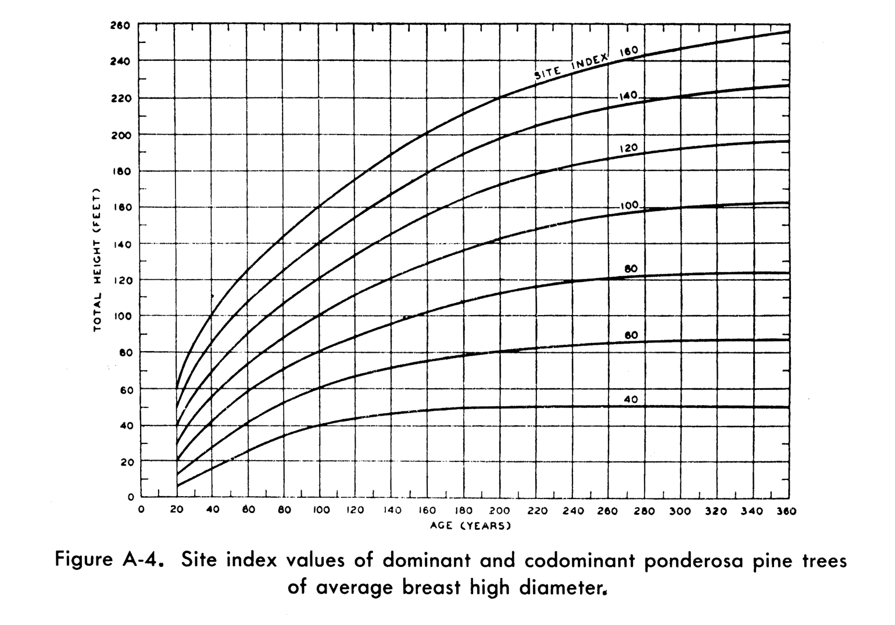
Fig 1. Ponderosa Pine Site Index Graph.

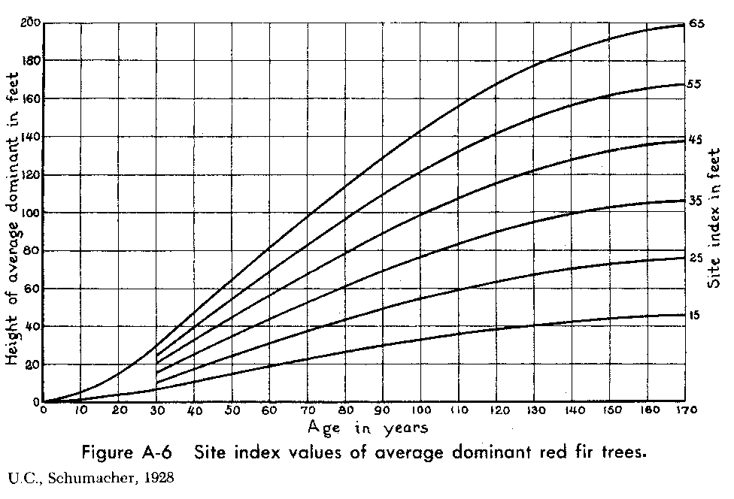

Fig. 2. Red Fir Site Index Graph.
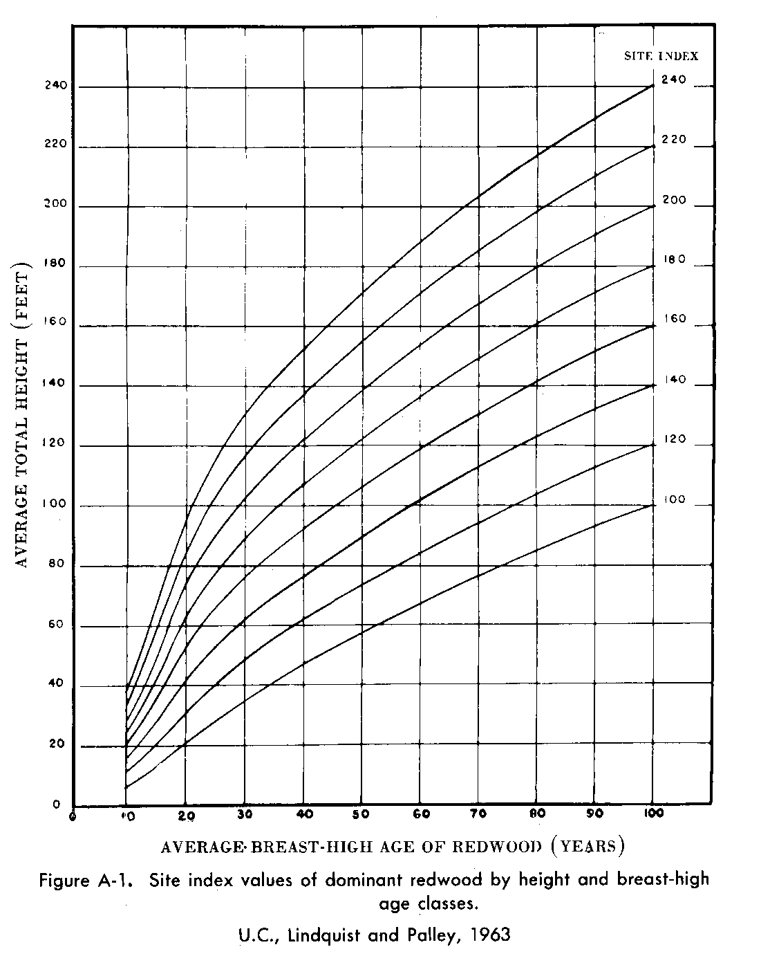

Fig. 3. Redwood Site Index Graph.

Appendix F -- Log Scaling

The following reference will be used for the log scaling portion of the Timber measurement Skillset, “National Forest Log Scaling Handbook” https://fs.fed.us/im/directives/fsh/2409.11/2409.11-NF%20LOGSCALING%20HDBK.pdf

Scaling Rules:
When logs are measured for length, they must be in even 2 foot increments that include 6 inches of trim if they do not have the needed 6 inches then they will be scaled to the next shorter 2 foot increment. For example a 16' 8" log would be scaled as a 16' log; a 16' 2" log would be scaled as a 14" log. Two segment logs must have a minimum of 1 foot of trim or 6 inches for each segment.

Rules for scaling butt logs:
20’ and under, no taper
22’ - 26’, 1” taper per segment, 2” total taper.
28’ - 40’, 2” taper per segment, 4” total taper

Appendix G -- Cruising Table

Tree Number | DBH | Ht | Volume in BF
1
2
3
4
5
6
7
8
9
10
Total Volume
Appendix H – Volume Table

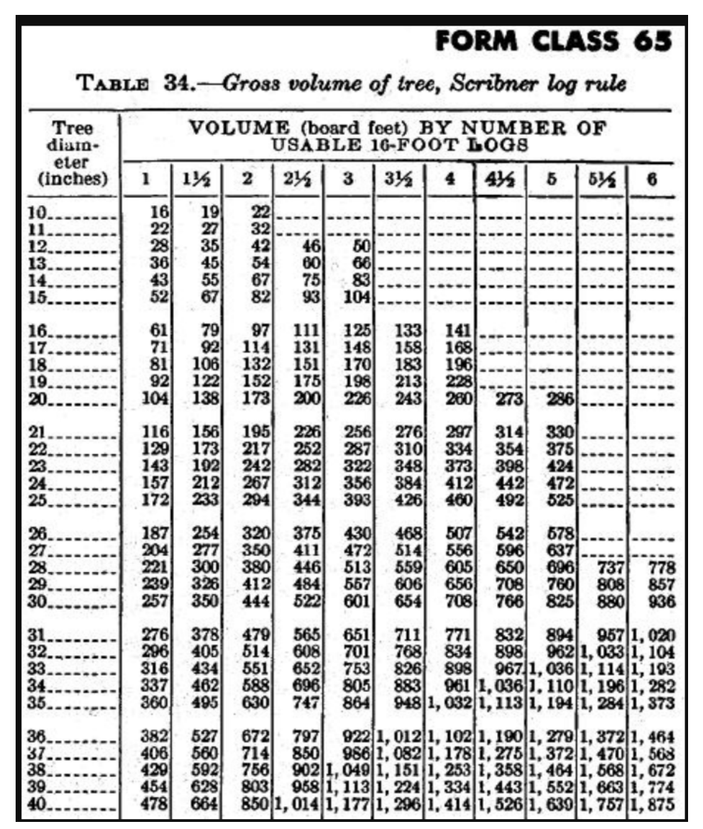

Appendix I – Basal Area

Basal Area: Skillset V (60 points- team score only)
 | Total Basal Area measured in  square feet per acre |  |  | 60
TOTAL |  |  |  | 60

Appendix J -- References

Anderson, Dave, I.I. Holland, and G.L. Rolfe. Forests and Forestry, fifth edition. Interstate Printers & Publishers, 1997. 558 pages.

Arvola, T. F. California Forestry Handbook. Sacramento: Office of Procurement Publications Section, 1978. 232 pages.

Chain Saw Manual, current edition, American Pulpwood Association, The Interstate Printers & Publishers, Inc., Danville, IL.

Dilworth, J. R. Log Scaling and Timber Cruising. Corvallis, Oregon: O.S.U. Bookstores, Inc., 1965. 448 pages.

Forest Curriculum Guidelines from VEP (Timber Cruising, Log Scaling, etc.)

Forestry Suppliers on-line equipment catalogue. 2003. Forestry Suppliers Inc.
Nov. 2003. <http://www.forestry-suppliers.com/>.

Helms, John A. The Dictionary of Forestry. Bethesda, MD: The Society of American Foresters, 1998. 210 pages.

Homelite Owner’s Manual. Division of Textron, P.O. Box 7047, Charlotte, NC 28217.

McMinn, Howard E. and Evelyn Maino. An Illustrated Manual of Pacific Coast Trees, second edition. Berkley: University California Press, 1981. 409 pages.

W. M. Harlow, E. S. Harrar, and F. M. White. Textbook of Dendrology, current edition. New York, NY: McGraw-Hill Book Company. 544 pages.

National Forest Log Scaling Handbook. San Francisco: US Forest Service and US Department of Agriculture, 1974. 184 pages.

Panshin, A.J. John and Carl DeZeeuw. Textbook of Wood Technology. The McGraw Hill Book Companies, 1980. 736 pages.

U.S. Department of Agriculture, Forest Service. Tables for Estimating Board-Foot Volume of Timber. No date. 94 pages.

U.S. Department of the Interior, Geological Survey, Topographic Map Information. A Symbols Key. Map Distribution, U.S. Geological Survey, Box 25286, Federal Center, Denver, CO 80223.

Wilson, A.L. and Robert L. Wilson,. Elementary Forest Surveying and Mapping. Corvallis, Oregon: John Bell & Associates, 1982. 108 pages.

